Grade 7 Accelerated · Unit 3 · Lesson 6–7  Evaluating and Equivalent Expressions  Independent Set 3.06 ANSWER KEY | Name  Date  Period

Six questions, on your own, in silence. Show the step that does the work.
1. Find the value. 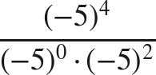

4 − 0 − 2 = 2.

2. Find the value. 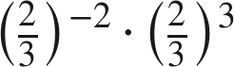
−2 + 3 = 1.

3. Write as a power of 2. 

16 = 2⁴.

4. Write as a power of 3. 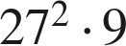

3⁶ · 3².

5. Are 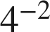 and 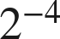 equivalent? Show why.
Yes — both are .
4⁻² = (2²)⁻² = 2⁻⁴.

6. Find the value. 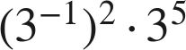

−2 + 5 = 3.

